**CIRCUIT:**

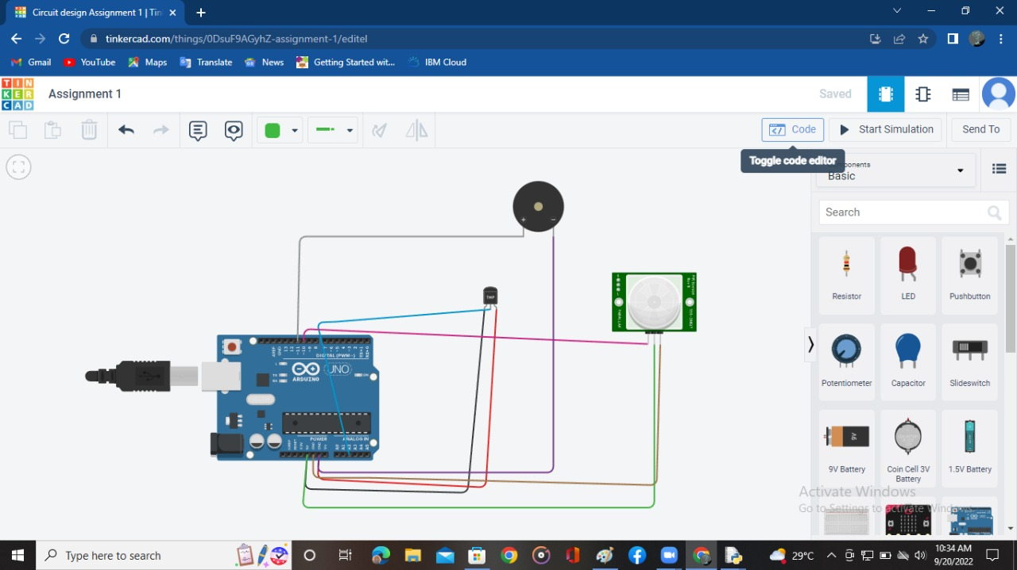

**TEMPERATURE CHANGING:**

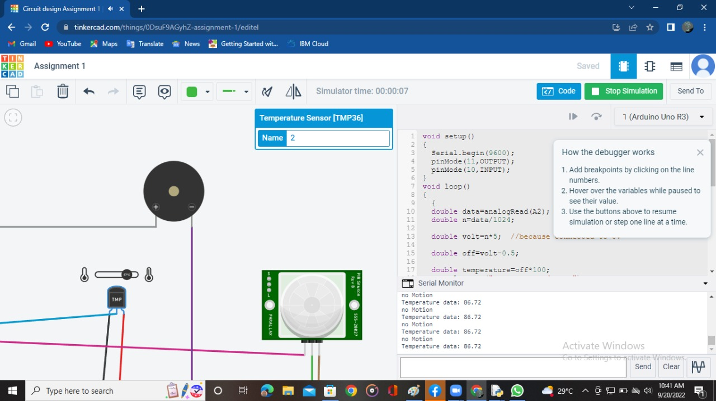

**MOITION DETECTING IN PIR SENSOR:**

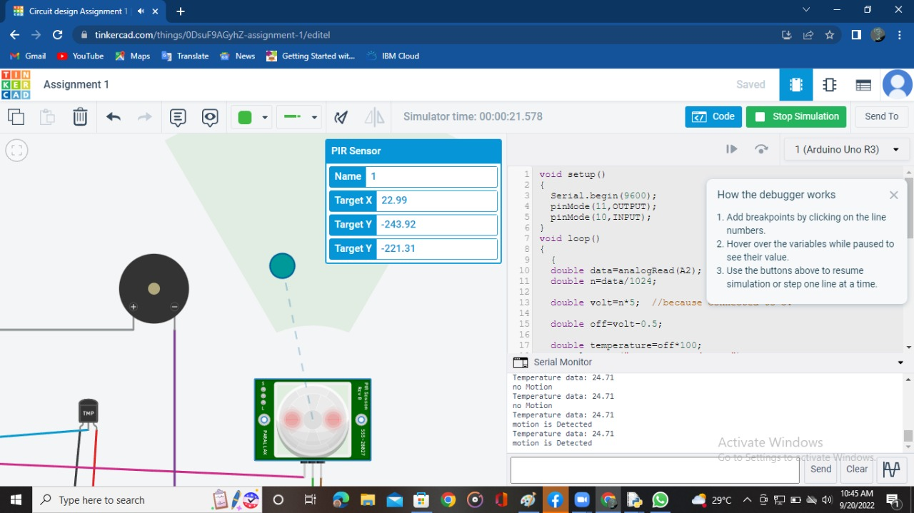

**CODE:**

void setup()

{

Serial.begin(9600);

pinMode(11,OUTPUT);

pinMode(10,INPUT);

}

void loop()

{

{

double data=analogRead(A2);

double n=data/1024;

double volt=n*5; //because connected to 5v

double off=volt-0.5;

double temperature=off*100;

Serial.print("Temperature data: ");

Serial.println(temperature);

if (temperature <=60)

{

digitalWrite(11,LOW);

}

else

{

digitalWrite(11,HIGH);

delay(1000);

digitalWrite(11,LOW);

delay(1000);

}

}

{

int motion=digitalRead(10);

if (motion==1){

Serial.println("motion is Detected ");

digitalWrite(11,HIGH);

delay(5000);

digitalWrite(11,LOW);

delay(500);

}

else{

Serial.println("no Motion");

digitalWrite(11,LOW);

}

}

}